How to access ASTM documents :

- Sign in McGill’s VPN
- Go to https://mcgill.worldcat.org/
- Search box: ASTM Standards
- Click on View now and on Access journal
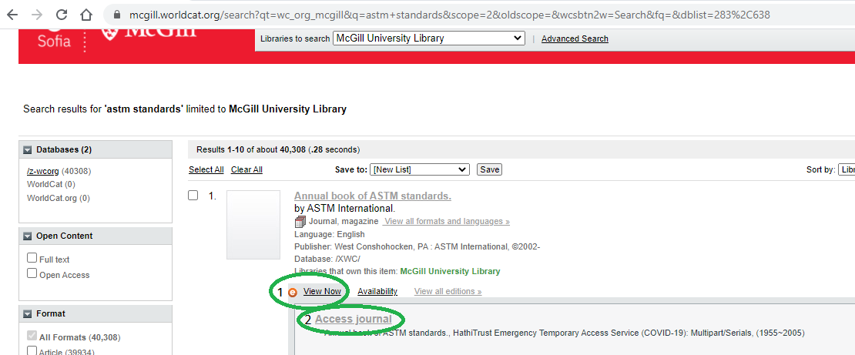
- This will lead you to a second identification system called shibboleth.mcgill.ca, enter your info
- You will then access the HathiTrust of the University of Michigan, it will ask you which data you want to be transmitted to the system, make your choice and click on Accept
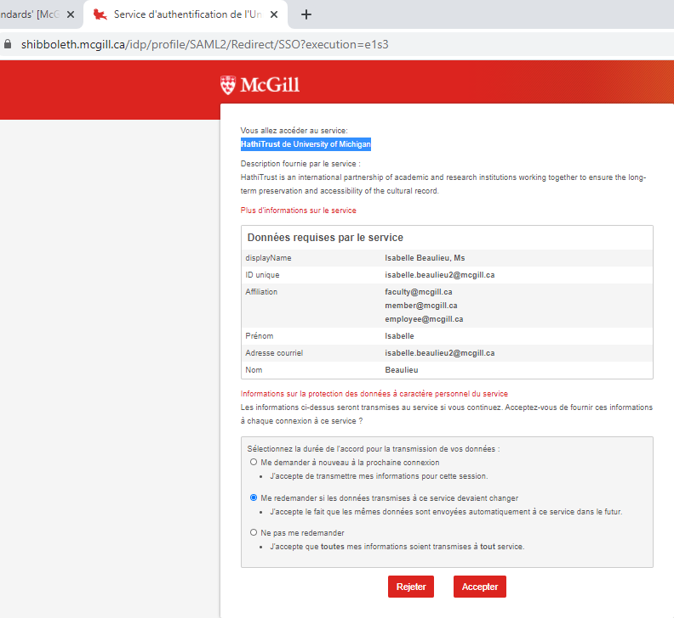

- You will then access the catalog https://catalog.hathitrust.org
- Click on the volume you want to access (temporary access)
ex: Temporary access 2004:15.09 University of Illinois at Urbana-Champaign
- Click on check out

- Once you are in the catalog you can also use the search box if the volume you want is not listed

